https://www.youtube.com/watch?v=oB5ctmEwzG8
Domain Driven Design

Domain represents a specific business functionality. For example, for hospital - we have Appointment , Clinical , Lab Management , Pharmacy
DDD – because everything starts with the domain .
2 phases – Strategic DDD & Tactical DDD

Strategy : The final GOAL what you want to do
Tactical : Action to achieve the final GOAL

Strategic : Core domain , supporting domain , generic domain , UL , context map , bounded context
Tactical : Entiteis , value objects , services , repository , aggregates , CQRS

Core domain : what makes business special ex (clinical)
Supporting domain : helps the core but not unique ex (appointment , accounting)

Bounded Context
It is a logical boundary inside/around the subdomain , where all the stake holders talk in a consistent vocabulary , follow same rules , talk same sentences and think in the same context with out Ambuity (ubiquitous language )

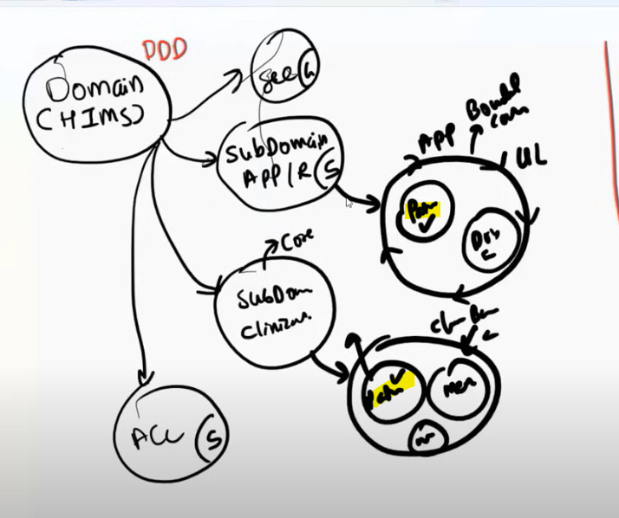

Patient in clinical bounded context , is all about medication . Whereas in appointment it is related to appointment specific .

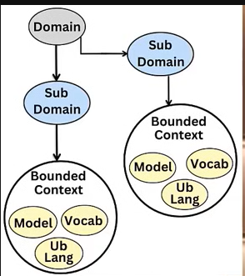

Context map , defines how the bounded context will interact , communicate , collaborate with each other.

Upstream : bounded context which produces /publishes data / events
Downstream : bounded context which depends / consumes data /events

9 Context Patterns

- Big ball of mud
- Shared kernel
- Conformist : one team works with what ever given by the other team as it is
- Supplier : provides the necessary data /events to customer in a Negotiated manner
- Anti corruption layer : is translation layer which converts / translates model / events / structures between bounded cotext
- Open host service : team publishes a service which follow well documented / defined services which follows standards can be consumed publicly with out knowing the internal complexities .
- Published language : team agrees on well defined / documented non-ambiguous shared language to communicate between bounded context .
- Partnership : team works on common goals in a collaborative manner . But are very much dependent on each other .
- Separate ways : teams work in a isolated manner with out collaboration or interaction

